***Penfolds St Henri Shiraz***

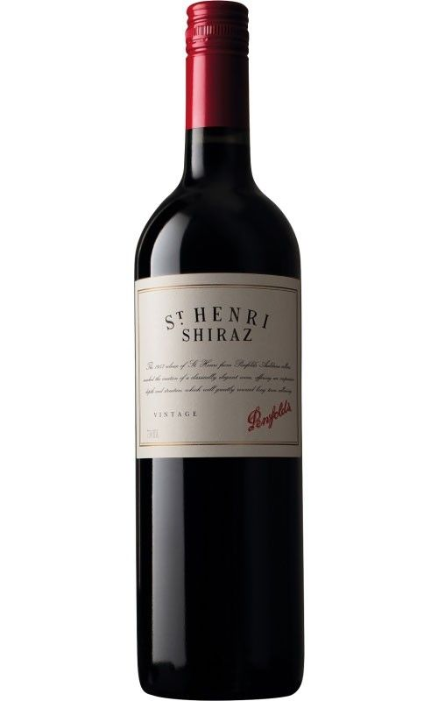

*Penfolds St Henri Shiraz Red Wine - a wine that celebrates the heritage of the Shiraz grape. Shiraz is harvested from Barossa Valley, McLaren Vale, Eden Valley, Port Lincoln, Australia. After fermentation, the wine is aged for 12 months in oak barrels.*